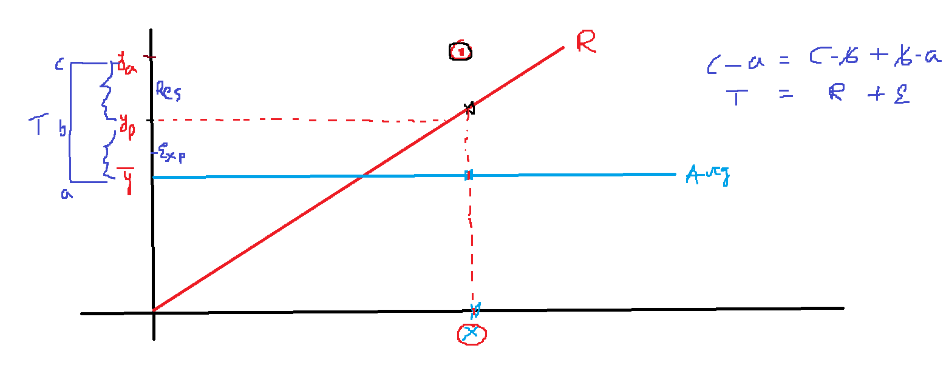

|  |  |  |
| --- | --- | --- |
|  |  |  |
|  |  |  |
|  |  |  |
|  |  |  |
|  |  |  |

|  |  |  |  |  |  |  |
| --- | --- | --- | --- | --- | --- | --- |
|  |  |  |  |  | : |  |
|  |  |  |  |  |  |  |
|  |  |  |  |  |  |  |
|  |  |  |  |  |  |  |
|  |  |  |  |  |  |  |
|  |  |  |  |  |  |  |

Below is a graph showing how the number lectures per day affects the number of hours spent at university per day. The equation of the [regression line](https://www.ncl.ac.uk/webtemplate/ask-assets/external/maths-resources/statistics/regression-and-correlation/simple-linear-regression.html#Least_Squares_Regression_Line.2C_LSRL) is drawn on the graph and it has equation ^y=0.143+1.229x�^=0.143+1.229�. Calculate R2�2.

This means that the number of lectures per day account for 89.589.5% of the variation in the hours people spend at university per day.

$$Sales=b_{o}+b_{1}*TV=====R-square=0.85$$

$$Sales=b_{o}+b_{1}*TV+b_{2}*Sm==R=0.90$$

$$Sales=b_{o}+b_{1}*TV+b_{2}*sm+b_{3}*NP==R=0.95$$

$$venky feels R-square 100 , so i use all the variables:Overfit$$

$$we need to control the R-square: Adjusted R-square$$

$$R-square varies 0 to 1$$

$$Adjusted R-square=0 to R-square$$

$$Sales=b_{o}+b_{1}*TV=====R-square=0.85;R_{Adj}-sq=0.85 (NP)$$

$$Sales=b_{o}+b_{1}*TV+b_{2}*Sm==R=0.90;R_{Adj}-sq=0.90 (NP)$$

$$Sales=b_{o}+b_{1}*TV+b_{2}*sm+b_{3}*NP==R=0.95; R_{Adj}-sq=0.92$$

$$R-square is problem because of Number of variables$$

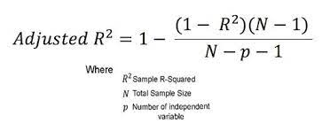

$$R_{adjusted}=1- \frac{\left(1-R_{squared}\right)}{N-p-1}*\left(N-1\right)$$

$$p=0: 1- \frac{\left(1-R_{squared}\right)}{N-1}*\left(N-1\right)$$

$$1-\left(1-R_{sq}\right)=R_{sq}$$